LED Strobe Wash Outdoor Moving Light

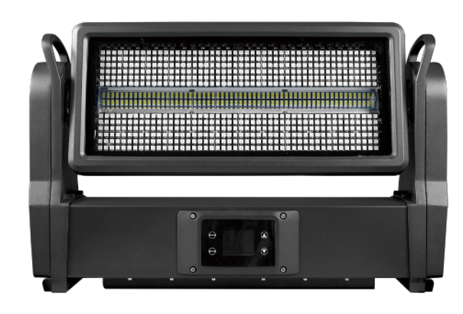

User Manual

一、 Definition of Display Panel and Keys
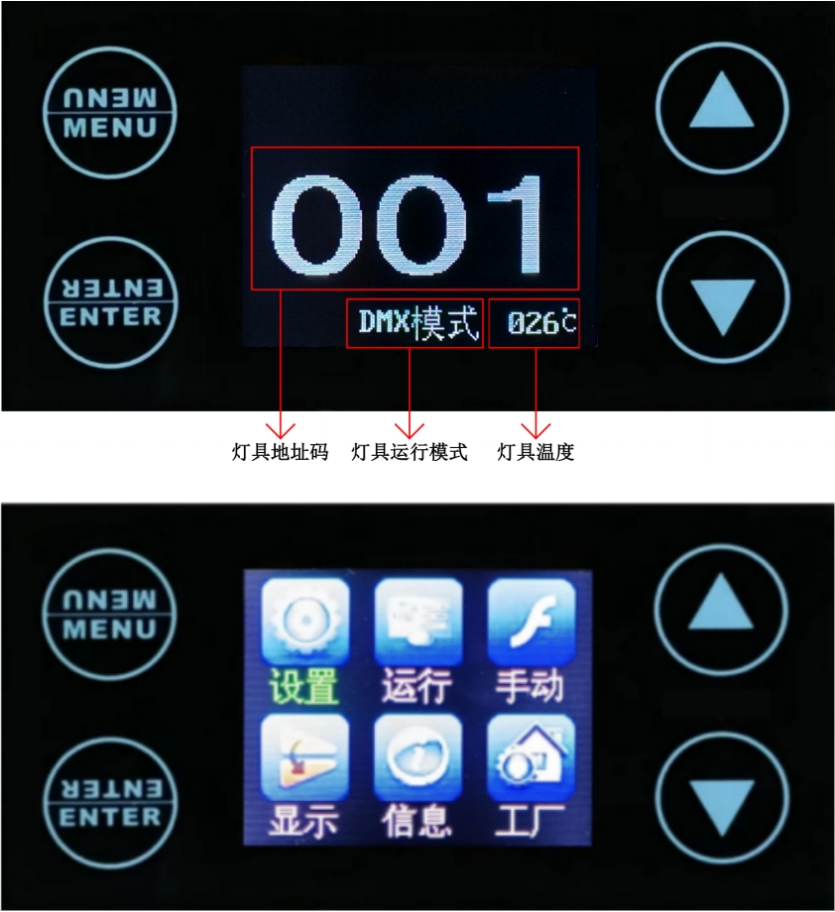

MENU key: enter/return to the main menu.
Up key [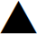](UP): menu function up selection/parameter increment.
Down key []: Down selection of menu function/decreasing of parameters.
ENTER key: select the menu function, and confirm and save it when the menu function parameters are modified.
The screen is automatically locked after a long period of no operation, and the screen needs to be unlocked in the operation menu.
Steps to unlock the screen: ① long press the UP key, ② DOWN key and ③ MENU)； key;
The display corresponding to the operation of the touch key will turn green (as shown in the figure below).
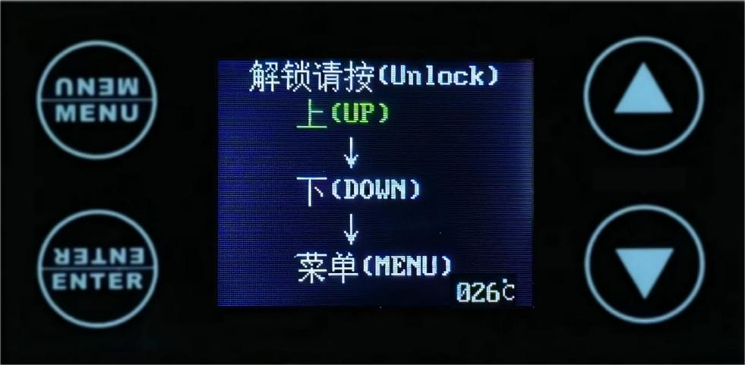

- Menu function
Primary menu | Submenu | Menu function description
1. System Settings | 1. DMX address | Set the DMX address code of lamps and lanterns, modify the value up/down (optional range 001-512), press the Enter key to save, and the default value is 001.
1. System Settings | 2. Encoder | Set the Y-axis software reset, modify the on/off up/down, save with the Enter key, and open by default.
1. System Settings | 3. Y inversion | Set the Y-axis running direction of lamps and lanterns to be reversed, modify the ON/OFF up/down, press the Enter key to save, and turn it off by default.
1. System Settings | 4. Advanced Settings | Lighting encryption settings.
2. Operation mode | 1.Operation mode | Set the running mode of lamps and lanterns, modify DMX/ voice control/automatic/manual up/down, and press the Enter key to save, which is DMX by default.
2. Operation mode | 2.Channel selection | Set the running channel of lamps and lanterns, select 8CH, 12CH, 17CH, 19CH, 162CH and 170CH up/down, and press the Enter key to save. The default is 19CH.
3. Manual control | 1.Y | Modify the Y-axis running angle value (range 000-255) up/down, and press the Enter key to save. The default value is 000.
3. Manual control | 2.Y fine-tuning | Modify the fine-tuning value of Y-axis running angle up/down (range 000-255), and press the Enter key to save. The default value is 000.
3. Manual control | 3. Y speed | Modify the value of Y-axis running speed up/down (range 000-255), and press the Enter key to save. The default value is 000.
3. Manual control | 4. Dimming | Modify the total dimming value of the light bulb up/down (range 000-255), and press the Enter key to save; the default value is 255.
3. Manual control | 5. Stroboscopic | Modify the strobe value up/down (range 000-255), and press the Enter key to save. The default value is 000.
3. Manual control | 6. Red | Modify the red brightness up/down (range 000-255), and press the Enter key to save. The default value is 128.
3. Manual control | 7. Green | Modify the green brightness up/down (range 000-255), and press the Enter key to save. The default value is 128.
3. Manual control | 8. Blue | Modify the blue brightness up/down (range 000-255), and press the Enter key to save. The default value is 128.
3. Manual control | 9. White | Modify the white brightness up/down (range 000-255), and press the Enter key to save. The default value is 128.
3. Manual control | 10. Colorful | Modify the colorful values up/down (range 000-255), and press OK to save. The default value is 000.
3. Manual control | 11. RGB mode | Modify the red, green and blue operation mode value (range 000-255) up/down, and press the Enter key to save. The default value is 000.
3. Manual control | 12.RGB speed | Modify the speed value of red, green and blue operation mode up/down (range 000-255), and press the Enter key to save, and the default value is 000.
3. Manual control | 13. W mode | Modify the value of white running mode up/down (range 000-255), and press the Enter key to save, and the default value is 128.
3. Manual control | 14. W speed | Modify the speed value of white running mode (range 000-255) up/down, and press the Enter key to save. The default value is 000.
3. Manual control | 15.RGBW mode | Modify the red, green, blue and white operation mode value (range 000-255) up/down, and press the Enter key to save; the default value is 000.
3. Manual control | 16.RGBW speed | Modify the speed value of red, green, blue and white running mode up/down (range 000-255), and press the Enter key to save. The default value is 000.
3. Manual control | 17.Background color | Modify the background color value up/down (range 000-255), and press OK to save. The default value is 000.
3. Manual control | 18.Background color light | Modify the brightness of the background color up/down (range 000-255), and press the Enter key to save. The default value is 000.
3. Manual control | 19.Reset | Select "Yes/No" for lamp reset up/down, and press "OK" to execute; the default is "No".
4. Display settings | 1.Language choice | Chinese /EN (English) display in the setting menu, select up/down, and press the Enter key to save. The default is Chinese.
4. Display settings | 2.Inverted display settings | Set the display to be inverted, select Close/Open up/down, press the Enter key to save, and close by default.
4. Display settings | 3.Screen saver settings | Set the screen to automatically turn off the screen, select Close/Open up/down, press the Enter key to save, and it will be turned on by default.
4. Display settings | 4.Software version | G4JA program identification code, which cannot be modified.
5. Information | 1. Information | The encryption setting is off (it will only be displayed after the lamps are encrypted).  Time 9999:00 (other values will not be displayed until the lamps are encrypted)  HALL 00000
6. Factory Settings | Please enter the password for display! Change it to 138 up or down, and then press the Enter key to enter the factory settings. | 1.Y calibration | Calibrate the Y-axis angle up/down, and press the Enter key to save. The default value is 128.
6. Factory Settings |  | 2.LED | Up/down, modify the lighting sequence of lamp bead color LEDA/LEDB, and confirm to save. The default value is LEDA.
6. Factory Settings |  | 3. Red | Modify the brightness parameter of the red light bulb up/down (range 000-255), and press the Enter key to save; the default value is 255.
6. Factory Settings |  | 4. Green | Modify the brightness parameter of the green light bulb up/down (range 000-255), and press the Enter key to save; the default value is 255.
6. Factory Settings |  | 5. Blue | Modify the brightness parameter of the blue light bulb up/down (range 000-255), and press the Enter key to save; the default value is 255.
6. Factory Settings |  | 6. White | Modify the brightness parameter of the blue light bulb up/down (range 000-255), and press the Enter key to save; the default value is 255. Recognize 205.
6. Factory Settings |  | 7. Current | Modify the current parameters (range 000-015) up/down, and press the Enter key to save. The default value is 004.
6. Factory Settings |  | 8. Speed | Modify the running speed of the motor up/down (range 000-007), and confirm to save.
6. Factory Settings |  | 9.Logo | Modify the boot screen display (range 000-001) up/down, and press the Enter key to save it. The default value is 000.
6. Factory Settings |  | 10. Temperature | Modify the temperature parameter (range 040-070) up/down, and press the Enter key to save. The default value is 060.
6. Factory Settings |  | 11. Temperature-Fan | Up/down, select Off/On Temperature-Fan Control, and enter key to save, which is turned on by default.

三、Master-slave control

There are two or more identical lamps connected by DMX three-core signal lines, all lamps are modified to any address code of 001~512, and any one is set as the master, while other lamps are slaves, and all slave displays do not flicker; When the master adjusts the effects of gradual change, pulse change, jump, voice control and self-walking, all slaves synchronize the effects of gradual change, pulse change, jump, voice control and self-walking.
Special attention: 1. Only one host can be set for a group of lamps. If there are multiple hosts, all lamps will flash without synchronization.
2. All lamps and lanterns must be used when the DMX512 console is closed.

四、DMX512 control
After electrifying, the address codes of all lamps and lanterns are set, and all lamps and lanterns are connected to the DMX512 console in parallel with three-core signal lines, and the address codes will stop flashing, indicating that the DMX512 console signal has been sent to the lamps and lanterns. According to each channel description, the DMX512 console is used to control related functions.

CH08 channel description:
Passage | Channel value | Fundamental function
1 | 000-255 | Y
2 | 000-255 | Y speed
3 | 000-255 | Stroboscopic
4 | 000-255 | R
5 | 000-255 | G
6 | 000-255 | B
7 | 000-255 | W
8 | 000-255 | Reset

CH12 channel description:
Passage | Channel value | Fundamental function
1 | 000-255 | Y
2 | 000-255 | Y fine tuning
3 | 000-255 | Y speed
4 | 000-255 | Aiming
5 | 000-255 | Stroboscopic
6 | 000-255 | R
7 | 000-255 | G
8 | 000-255 | B
9 | 000-255 | W
10 | 000-255 | RGBW mode
11 | 000-255 | RGBW speed
12 | 000-255 | Reset

CH17 channel description:
Passage | Channel value | Fundamental function
1 | 000-255 | Y
2 | 000-255 | Y fine tuning
3 | 000-255 | Y speed
4 | 000-255 | Aiming
5 | 000-255 | Stroboscopic
6 | 000-255 | R
7 | 000-255 | G
8 | 000-255 | B
9 | 000-255 | W
10 | 000-255 | Colour
11 | 000-255 | RGB mode
12 | 000-255 | RGB speed
13 | 000-255 | W mode
14 | 000-255 | W speed
15 | 000-255 | RGBW mode
16 | 000-255 | RGBW speed
17 | 000-255 | Reset

CH19 channel description:
Passage | Channel value | Fundamental function
1 | 000-255 | Y
2 | 000-255 | Y fine tuning
3 | 000-255 | Y speed
4 | 000-255 | Aiming
5 | 000-255 | Stroboscopic
6 | 000-255 | R
7 | 000-255 | G
8 | 000-255 | B
9 | 000-255 | W
10 | 000-255 | Colour
11 | 000-255 | RGB mode
12 | 000-255 | RGB speed
13 | 000-255 | W mode
14 | 000-255 | W speed
15 | 000-255 | RGBW mode
16 | 000-255 | RGBW speed
17 | 000-255 | Background color
18 | 000-255 | Background dimming
19 | 000-255 | Reset

CH162 channel description:
Passage | Channel value | Fundamental function
1 | 000-255 | Y
2 | 000-255 | Y fine tuning
3 | 000-255 | Y speed
4 | 000-255 | Reset
5 | 000-255 | Aiming
6 | 000-255 | Stroboscopic
7 | 000-255 | R1
8 | 000-255 | G1
9 | 000-255 | B1
… | … | … …
148 | 000-255 | R48
149 | 000-255 | G48
150 | 000-255 | B48
151 | 000-255 | W1
152 | 000-255 | W2
153 | 000-255 | W3
154 | 000-255 | W4
155 | 000-255 | W5
156 | 000-255 | W6
157 | 000-255 | W7
158 | 000-255 | W8
159 | 000-255 | W9
160 | 000-255 | W10
161 | 000-255 | W11
162 | 000-255 | W12

CH170 channel description:
Passage | Channel value | Fundamental function
1 | 000-255 | Y
2 | 000-255 | Y fine tuning
3 | 000-255 | Aiming
4 | 000-255 | Stroboscopic
5 | 000-255 | Colour
6 | 000-255 | RGB mode
7 | 000-255 | RGB speed
8 | 000-255 | W mode
9 | 000-255 | W speed
10 | 000-255 | RGBW mode
11 | 000-255 | RGBW speed
12 | 000-255 | Background color
13 | 000-255 | Background dimming
14 | 000-255 | Reset
15 | 000-255 | R1
16 | 000-255 | G1
17 | 000-255 | B1
… | … | … …
156 | 000-255 | R48
157 | 000-255 | G48
158 | 000-255 | B48
159 | 000-255 | W1
160 | 000-255 | W2
161 | 000-255 | W3
162 | 000-255 | W4
163 | 000-255 | W5
164 | 000-255 | W6
165 | 000-255 | W7
166 | 000-255 | W8
167 | 000-255 | W9
168 | 000-255 | W10
169 | 000-255 | W11
170 | 000-255 | W12

五、Technical parameters:
Voltage: AC100~240V 50/60HZ.
Power: 600W
Lamp beads: 240 3030 white 2-watt 768 5050 RGB-0.5-watt lamp beads.
Control mode: DMX512, Self-propelled, Master-slave, Voice control and RDM function.
Channels: CH08, CH12, CH17, CH19, CH162, CH170.
Dimming: 0~100% linear dimming.
Features: y shaking head+dyeing+flashing.
Working temperature: -30 ~60 degrees.
Strobe frequency: 1~25HZ.
Appearance: metal, black.
Connection mode: DMX512 input/output/power input/output.
IP grade: IP65

